KESS V2 Wake up error, How to Solve?

If you get "Wake up error" when running Kess v2 as the following picture shows.

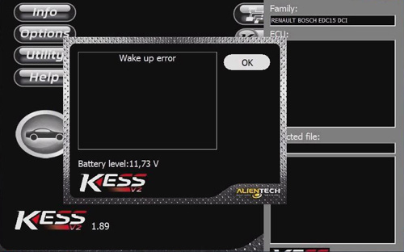

Possible reasons for wake up error:
Kess v2 fails to read out TF card program or the program in the TF card is not working properly.

2 reasons for Kess v2 fails to read out TF card program.
1) The four pins of chip are not soldered firmly on the main board.
2) The chip is loose for a long time of use.
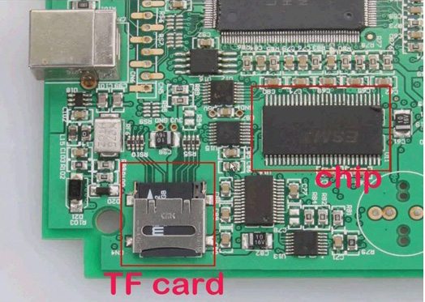

Try to do as following instruction:
- Solder the chip once more to make it tightly connected to the main board.
- Clean up the shrapnel on the card slot with a brush.
- Lift up the shrapnel a little bit to make sure it can well communicate with the TF card, if the card slot shrapnel is not flexible enough.
- Clean the TF card and then put it back to the card slot.
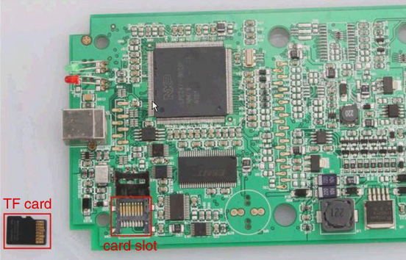

If the wake up error stays, format the card and then copy the software back to the card.
It is easy 3 basic steps, pay attention to the important note.
- Format TF card
- Ask us to send you the software in the TF card
3: decompress the file, choose them all, copy and paste to TF card. (IMPORTANT NOTE: Don’t directly copy the compressed file to TF card; don’t create a new folder in TF card and copy decompressed file into it.)
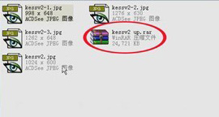
(1. Decompress file: kessv2 up)

(2. Copy the 4 files and paste to TF card)

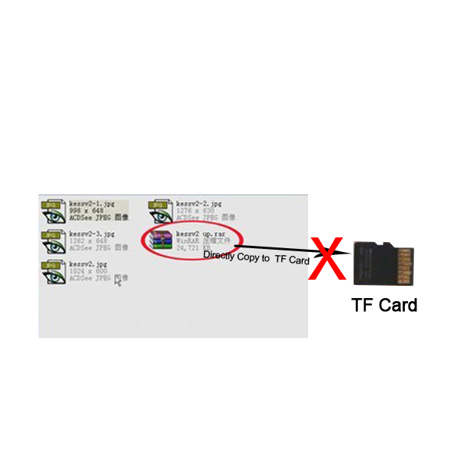
(Wrong operation)

If the two methods above do not work out wake up error, reflash the CPU program, and then copy and paste the software to the TF card again. The procedure to reflash CPU is as the same as that to solve token limitation as the following link shows:
http://www.eobd2.fr/kess-v2-obd2-manager-tuning-kit-2589.html

