Steps to Program ID46 Nissan Key with SKP900
Step 1 Connect SKP900 Key Programmer to a Nissan OBDⅡconnector via Main Cable, start the car with a remote and wait a few seconds for SKP900 to start.
Step 2 Select Nissan, New Structure and choose Yes to continue.
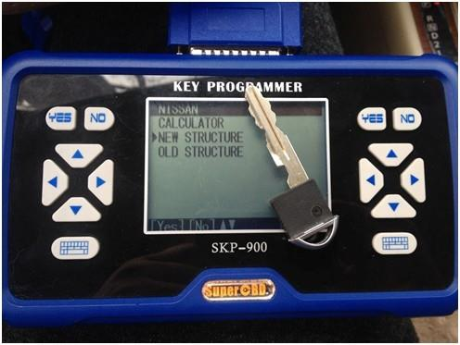
Step 3 Select Key 1 and choose Yes
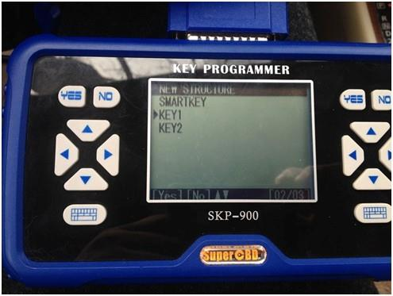
Step 4 Select Immobilizer System according to the cars Immo and choose Yes.
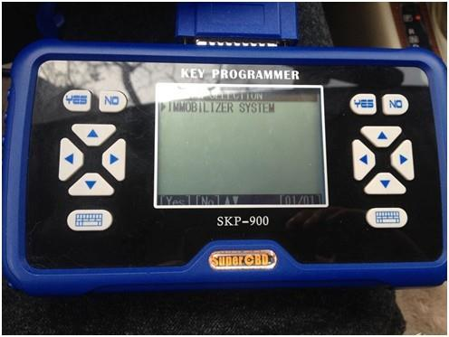
Step 5 Wait for a few minutes until SKP900 communicates with the car.
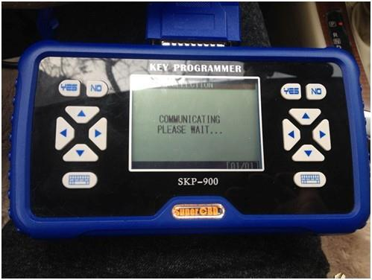
Step 6 Select Function, System Selection then Key Adapt and choose Yes.
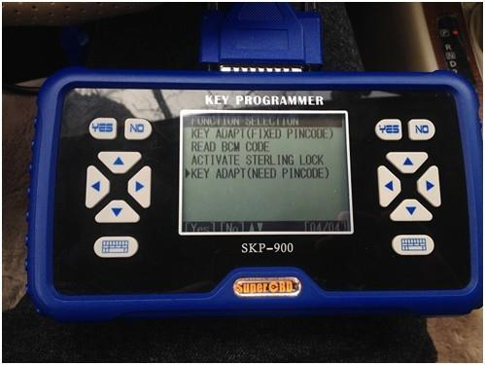
Step 7 Choose Yes.
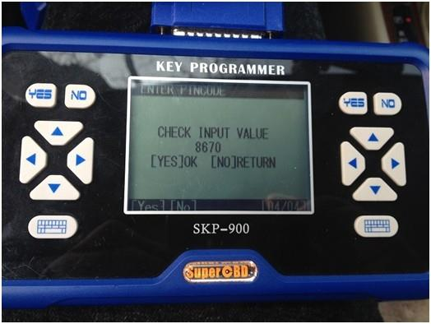
Step 8 According to the instruction on screen, you should insert a new key and turn IGN on. You may see the IMMO indicator light will flash when inserting a key which cannot start engine. Select Yes.
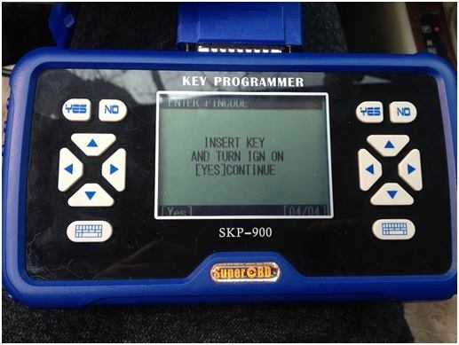
Step 9 Close IGN switch and select Yes.
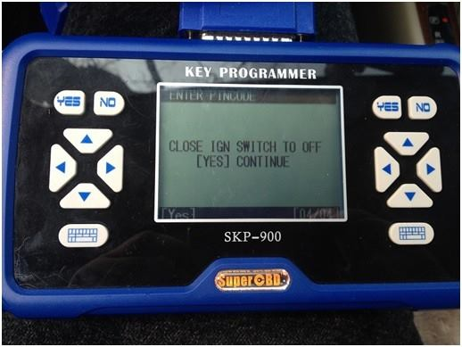
Step 10 Wait for system adapting and then open IGN switch and select Yes.
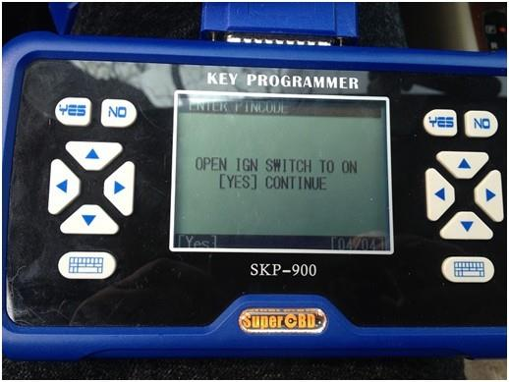
Step 11 Wait for a few minutes and the key is programmed successfully.
